Sorting Algorithms (Cheat Sheet)

🫧 Bubble Sort

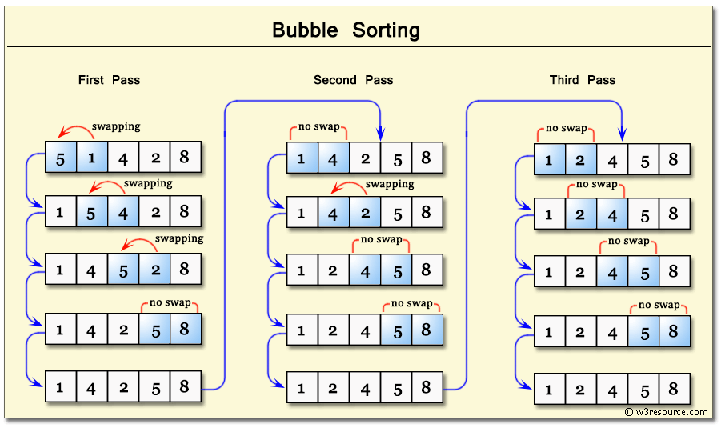

Idea
Repeatedly compare neighbors and swap if they are in the wrong order. After each round, the largest unsorted value moves to the end.
How it runs
- Traverse from start to end
- Swap adjacent wrong pairs
- Shrink the unsorted portion
- Repeat
Complexity
- Best: O(n) with optimization
- Average: O(n²)
- Worst: O(n²)
- Space: O(1)
Use when
Mostly educational or when the array is almost sorted.

🎯 Selection Sort

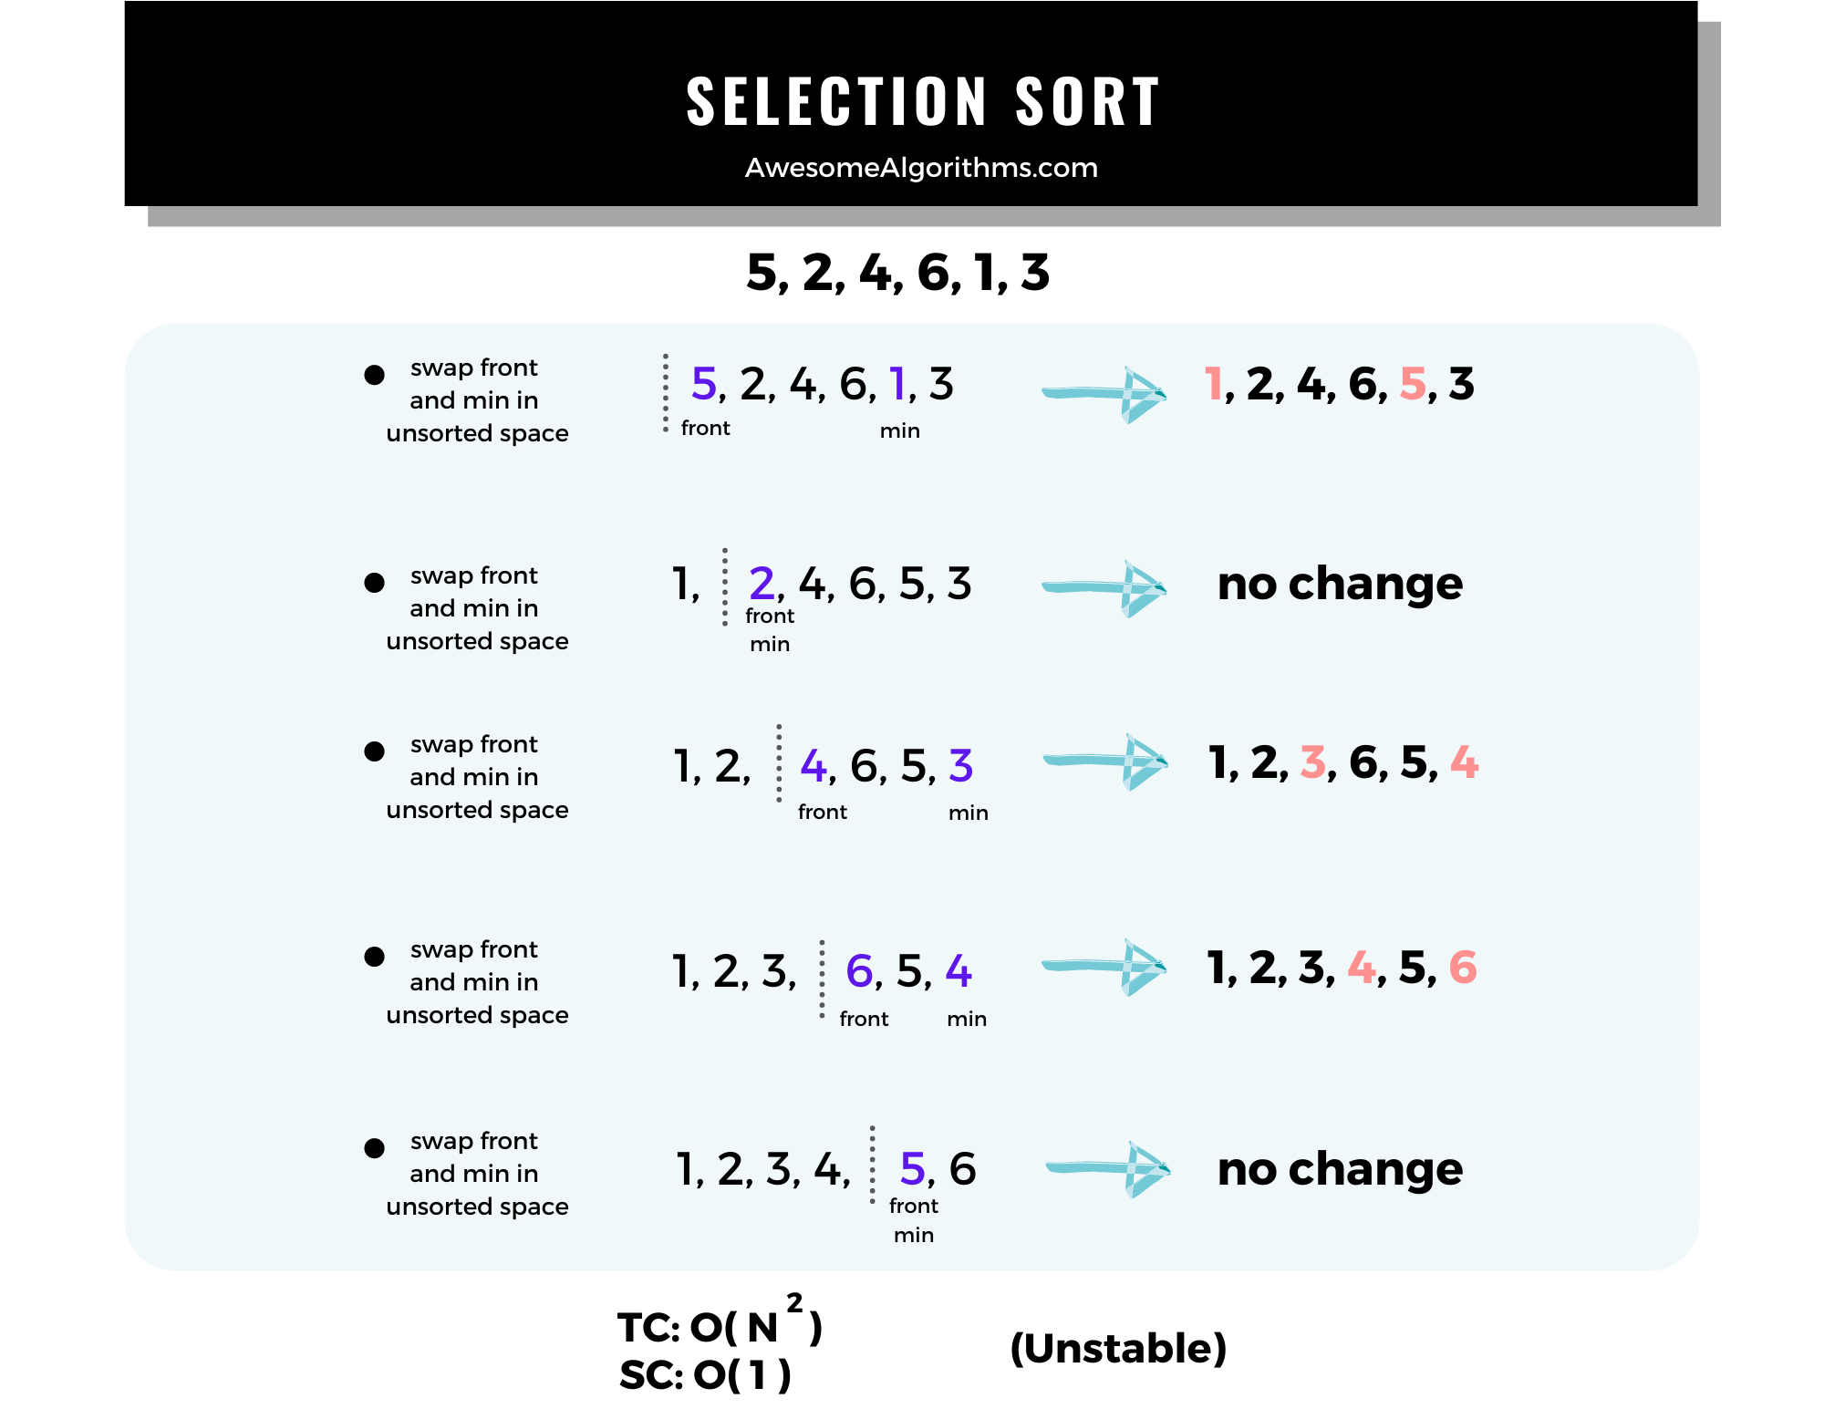
Idea
Find the minimum from the unsorted part and put it at the correct index.
How it runs
For each position i:
- find smallest element from i to end
- swap with i
Complexity
- Best: O(n²)
- Average: O(n²)
- Worst: O(n²)
- Space: O(1)
Use when
When swaps are expensive but comparisons are cheap.

🧩 Insertion Sort

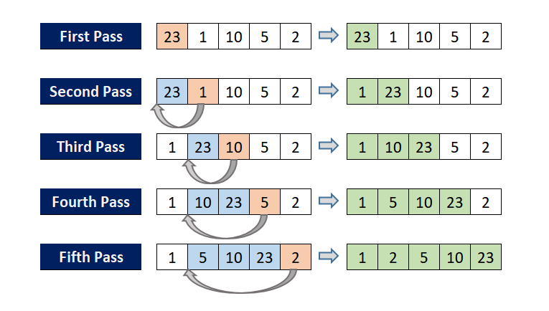
Idea
Build a sorted portion one element at a time by inserting each new value where it belongs.
How it runs
- Assume left side is sorted
- Take current element
- shift larger values right
- insert at correct spot
Complexity
- Best: O(n)
- Average: O(n²)
- Worst: O(n²)
- Space: O(1)
Use when
Small input or nearly sorted data.

🔀 Merge Sort
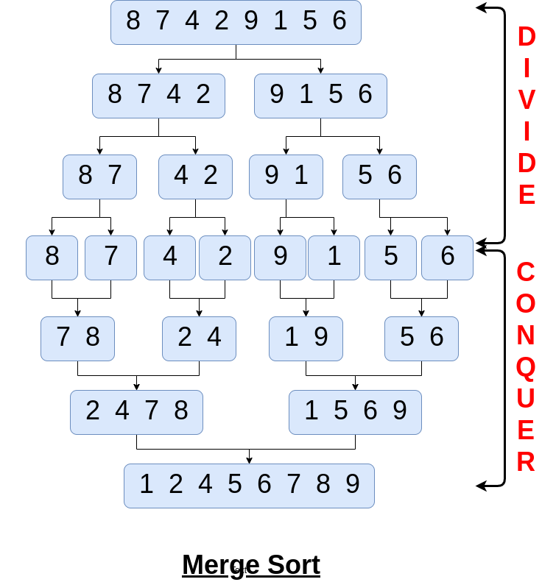

Idea
Divide into halves, sort each half, merge them.
How it runs
- Split until single elements
- Merge while sorting
- Combine results
Complexity
- Best: O(n log n)
- Average: O(n log n)
- Worst: O(n log n)
- Space: O(n)
Use when
Need guaranteed performance or stable sorting.

⚡ Quick Sort
Idea
Choose a pivot, place it correctly, then sort left and right parts.
How it runs

- Average: O(n log n)
- Worst: O(n²)
- Space: O(log n) average due to recursion
Use when
Very fast in practice, in place, great cache behavior.
- pick pivot
- partition into smaller and larger
- recurse
Complexity
- Best: O(n log n)

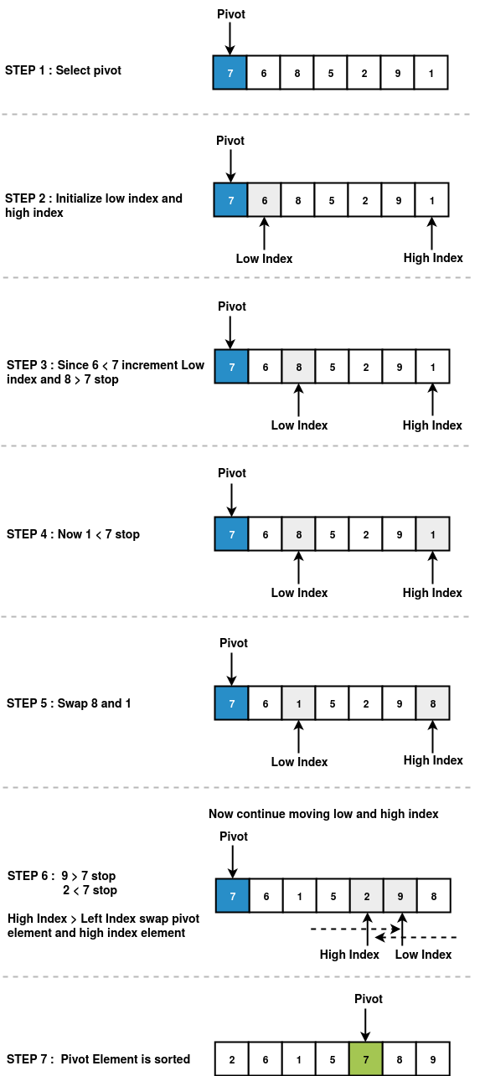

Problems
🟢 Easy Tier
Merge Sorted Array (88)
Classic two pointer merge.
Tests understanding of stable ordering.
Squares of a Sorted Array (977)
Transformation breaks order → restore with two pointers.
Height Checker (1051)
Compare original vs sorted copy.
Sort Array by Increasing Frequency (1636)
Frequency map + custom comparator.

🟡 Medium Tier
Sort Colors (75)
Special case of sorting with constant values.
Dutch national flag problem.
Largest Number (179)
Comparator creativity: "a+b" vs "b+a".
Merge Intervals (56)
Sort by start → greedy sweep.
Queue Reconstruction by Height (406)
Sort by height desc, insert by index.
Minimum Number of Arrows to Burst Balloons (452)
Sort by end → greedy pick.
Car Fleet (853)
Sort by position → process from back.
K Closest Points to Origin (973)
Sort or heap using distance.

🔴 Hard Tier
Count of Smaller Numbers After Self (315)
Modified merge sort with counting.
Maximum Number of Events That Can Be Attended (1353)
Sort by start day + heap.
The Skyline Problem (218)
Sort edges + priority structure.

⚡ What Interviewers Actually Check
They want to know if you can:
✔ decide sorting will simplify chaos
✔ define correct comparator
✔ combine sorting + greedy
✔ use sorting with heap
✔ convert problem into interval or sweep line

🎯 Most Asked In Interviews
If time is limited, master these first:
56, 75, 179, 406, 452, 347, 973

